Activity: Add and manage users with Linux commands
experimentLabschedule1 houruniversal_currency_altNo costshow_chartIntroductory
infoThis lab may incorporate AI tools to support your learning.

Activity overview
Previously, you focused on authorization, the concept of granting access to specific resources in a system. Another important concept in security is authentication. Authentication is the process of a user proving that they are who they say they are in the system.
When managing this, security analysts need to ensure
- not all users get access to the system,
- new users (those who are new to the organization or a group) are added to the system, and
- current users who change groups or leave the organization are deleted from the system.
In this lab activity, you’ll use the useradd, usermod, userdel, and chown commands to manage user access in the Linux Bash shell.
Important: You must use sudo at the beginning of all the commands you use in this lab. Adding or removing users and groups are tasks that require root (super user) privileges, and you’ll need to use sudo with the commands that are used to perform these tasks.

Scenario
In this scenario, a new employee with the username researcher9 joins an organization. You have to add them to the system and continue to manage their access during their time with the organization.
Here’s how you’ll do this task: First, you’ll add a new employee to the system and then to their primary group. Second, you’ll make this employee the owner of a file related to a particular project. Third, you’ll add the new employee to a supplementary group. Finally, you’ll delete the employee from the system.
Note: The lab starts with you logged in as user analyst, with your home directory, /home/analyst, as the current working directory.
OK, it’s time to get ready to practice managing user access in Linux!
Disclaimer: For optimal performance and compatibility, it is recommended to use either Google Chrome or Mozilla Firefox browsers while accessing the labs.

Start your lab
You'll need to start the lab before you can access the materials. To do this, click the green “Start Lab” button at the top of the screen.

After you click the Start Lab button, you will see a shell, where you will be performing further steps in the lab. You should have a shell like this:
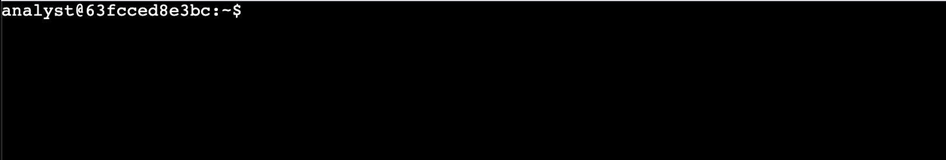
When you have completed all the tasks, refer to the End your Lab section that follows the tasks for information on how to end your lab.

Task 1. Add a new user
A new employee has joined the Research department. In this task, you must add them to the system. The username assigned to them is researcher9.
- Write a command to add a user called researcher9 to the system.
Next, you need to add the new user to the research_team group.
- Use the usermod command and -g option to add researcher9 to the research_team group as their primary group.
Click Check my progress to verify that you have completed this task correctly.
Add a new user

Task 2. Assign file ownership
The new employee, researcher9, will take responsibility for project_r. In this task, you must make them the owner of the project_r.txt file.
The project_r.txt file is located in the /home/researcher2/projects directory, and owned by the researcher2 user.
- Use the chown command to make researcher9 the owner of /home/researcher2/projects/project_r.txt.
Click Check my progress to verify that you have completed this task correctly.
Assign file ownership

Task 3. Add the user to a secondary group
A couple of months later, this employee's role at the organization has changed, and they are working in both the Research and the Sales departments.
In this task, you must add researcher9 to a secondary group (sales_team). Their primary group is still research_team.
- Use the usermod command with the -a and -G options to add researcher9 to the sales_team group as a secondary group.
Note: Options for Linux commands are case-sensitive, so make sure you use a lowercase -a and an uppercase -G.
Click Check my progress to verify that you have completed this task correctly.
Add the user to a secondary group

Task 4. Delete a user
A year later, researcher9, decided to leave the company. In this task, you must remove them from the system.
- Run a command to delete researcher9 from the system:
sudo userdel researcher9
Copied!
This command will output the following message:
Userdel: Group researcher9 not removed because it is not the primary group of user researcher9.
This is expected.
Note: When you create a new user in Linux, a group with the same name as the user is automatically created and the user is the only member of that group. After removing users, it is good practice to clean up any such empty groups that may remain behind.
- Run the following command to delete the researcher9 group that is no longer required:
sudo groupdel researcher9
Copied!
Click Check my progress to verify that you have completed this task correctly.
Delete a user

Conclusion
Great work!
You now have practical experience in using basic Linux Bash shell commands to
- add a new user,
- add a user to a group,
- change user permissions on files, and
- delete a user.
This is an important milestone on your journey toward managing users in Linux!

End your lab
Before you end the lab, make sure you’re satisfied that you’ve completed all the tasks, and follow these steps:
- Click End Lab. A pop-up box will appear. Click Submit to confirm that you're done. Ending the lab will remove your access to the Bash shell. You won’t be able to access the work you've completed in it again.
- Another pop-up box will ask you to rate the lab and provide feedback comments. You can complete this if you choose to.
- Close the browser tab containing the lab to return to your course.
- Refresh the browser tab for the course to mark the lab as complete.

